Videoles 19

Toonladder G:

1 1 ½ 1 1 1 ½
G – A – B-C – D – E – F#-G

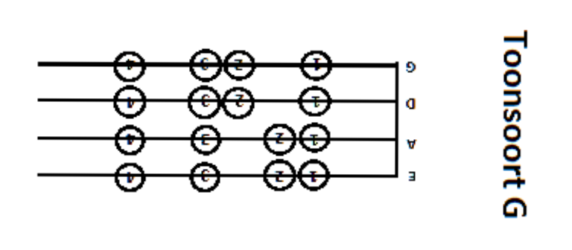
Happy Birthday
D A D
0 0. 1 0 3 2 0 0. 1 0 4 3 0 0. 3 1 3 2 1

A D
2 2. 1 3 4 3

